- Copyright for test papers and marking guides remains with West Australian Test Papers.
- The papers may only be reproduced within the purchasing school according to the advertised conditions of sale.
- Test papers must be withdrawn after use and stored securely in the school until Wednesday 10th October 2018.



CHEMISTRY
UNIT 3 & 4
2018

MARKING GUIDE

Section One: Multiple-choice (50 marks)

1 | a □ b ■ c □ d □ |  | 11 | a □ b ■ c □ d □ |  | 21 | a □ b □ c ■ d □
2 | a ■ b □ c □ d □ |  | 12 | a ■ b □ c □ d □ |  | 22 | a □ b □ c ■ d □
3 | a □ b □ c ■ d □ |  | 13 | a ■ b □ c □ d □ |  | 23 | a □ b □ c ■ d □
4 | a □ b □ c □ d ■ |  | 14 | a ■ b □ c □ d □ |  | 24 | a □ b □ c □ d ■
5 | a □ b □ c □ d ■ |  | 15 | a □ b ■ c □ d □ |  | 25 | a □ b □ c □ d ■

6 | a □ b □ c □ d ■ |  | 16 | a □ b □ c ■ d □
7 | a ■ b □ c □ d □ |  | 17 | a □ b □ c ■ d □
8 | a □ b □ c ■ d □ |  | 18 | a □ b □ c ■ d □ |  |  | (2 marks per question)
9 | a □ b ■ c □ d □ |  | 19 | a □ b □ c □ d ■
10 | a □ b ■ c □ d □ |  | 20 | a □ b ■ c □ d □

Section Two: Short answer 35% (70 marks)

This section has 8 questions. Answer all questions. Write your answers in the spaces provided.

When calculating numerical answers, show your working or reasoning clearly. Express numerical answers to the appropriate number of significant figures and include appropriate units where applicable.

Spare pages are included at the end of this booklet. They can be used for planning your responses and/or as additional space if required to continue an answer.
- Planning: If you use the spare pages for planning, indicate this clearly at the top of the page.
- Continuing an answer: If you need to use the space to continue an answer, indicate in the original answer space where the answer is continued, i.e. give the page number. Fill in the number of the question(s) that you are continuing to answer at the top of the page.

Suggested working time: 60 minutes.

Question 26 (6 marks)

Consider the lead-acid accumulator battery used in most common vehicles. The lead-acid accumulator provides the energy required to start the vehicle’s engine, as well as having the ability to recharge itself whilst the vehicle is being driven. Explain (noting that chemical equations are not required in your answer) how this cell can be classified as both;

(a) a galvanic cell. (3 marks)

- when it produces electricity to start the car it is acting as a galvanic cell
- this type of cell uses a stored oxidant and reductant
- produces electricity via a spontaneous redox reaction OR converts chemical energy into electrical energy

(b) an electrolytic cell. (3 marks)

- when it is recharging it is acting as an electrolytic cell
- this type of cell uses electrical energy to drive a chemical reaction
- this forces a non-spontaneous reaction to occur, ie products back into reactants OR converts electrical energy into chemical energy

Question 27 (9 marks)

The bombardier beetle produces a ‘chemical bomb’ from the reaction between hydroxyquinone and hydrogen peroxide. The beetle produces and stores these chemicals, as well as the peroxidase enzyme required to catalyse the reaction. As the chemicals combine and react, heat and gas is produced and the resulting pressure forces the chemical products out of the beetle’s abdomen with a loud bang. The beetle uses this as a defence mechanism.

The relevant chemical equation is;

C₆H₆O₂(l) + H₂O₂(l) → C₆H₄O₂(l) + H₂O(g) + O₂(g)
hydroxyquinone + hydrogen → benzoquinone + steam + oxygen
peroxide gas

(a) Sketch a labelled energy profile diagram for this reaction. Label the heat of reaction and the activation energy. (3 marks)

Progress of reaction
Potential energy (kJ)
Ea
ΔH
(1) shape
(1) Ea
(1) ΔH
(b) Add to the energy profile diagram above, the effect of the peroxidase enzyme. (1 mark)

- see dashed line on EPD above

(c) Determine whether hydroxyquinone is reduced or oxidised in this reaction. Use oxidation numbers to support your answer. (2 marks)

- oxidised
- oxidation number of carbon changes from (-1/3) to (0)
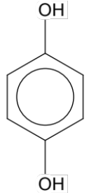
(d) The structure of hydroxyquinone is shown below. Classify hydroxyquinone as a primary, secondary or tertiary alcohol. Justify your answer. (2 marks)

- secondary
- the C with the OH group is attached to 2 other carbons

(e) What functional group do you predict will be present in benzoquinone? (1 mark)

- ketone OR C=O group

Question 28 (10 marks)

(a) Give the IUPAC name for each of the organic molecules below. (2 marks)

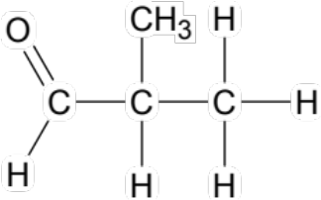 | 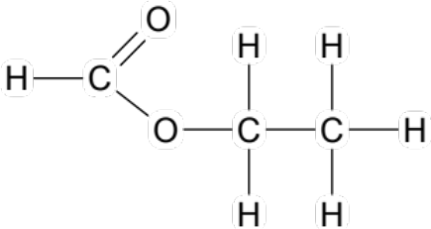
IUPAC Name:  Methylpropanal (accept 2-methylprolanal) | IUPAC Name:  ethyl methanoate

Acidified sodium dichromate solution was added to a sample of each of the substances in (a).

(b) Explain, with the use of an appropriate chemical equation, how this test would allow the substances to be distinguished. (4 marks)

- with ethyl methanoate no reaction would be observed, mixture would remain orange (1)
- with methyl propanal the orange mixture would become deep green (1)

- 3 CH₃CH(CH₃)CHO + Cr₂O₇²⁻ + 8 H⁺ → 3 CH₃CH(CH₃)COOH + 2 Cr³⁺ + 4 H₂O (2)

award 1 mark if oxidation half-equation is written correctly
[ox: CH₃CH(CH₃)CHO + H₂O → CH₃CH(CH₃)COOH + 2H⁺ + 2e⁻ ]
[red: Cr₂O₇²⁻ + 14 H⁺ + 6 e⁻ → 2 Cr³⁺ + 7 H₂O ]

(c) Draw the structures of the organic molecules named below. (2 marks)

1,1-dibromobutan-2-amine | 1,4,5-trifluoro-cis-pent-2-ene
Structural diagram:  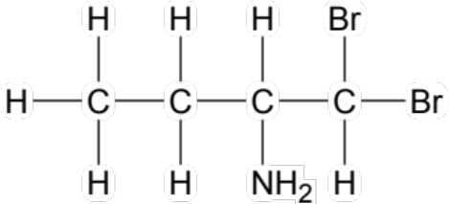 | Structural diagram:  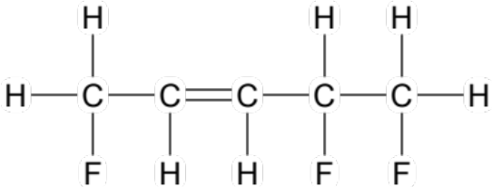

A few drops of green universal indicator were added to a sample of each of the substances in (c).

(d) Explain how this test would allow the substances to be distinguished. (2 marks)

- amine would be basic, therefore indicator would turn purple or blue
- alkene would be neutral, therefore indicator would stay green

Question 29 (8 marks)

A student had five (5) small pieces of iron and placed one piece into each of the solutions listed below.

- tap water, H₂O(l)
- calcium chloride, CaCl₂(aq)
- acidified potassium permanganate, KMnO₄(aq) / H⁺(aq)
- silver nitrate, AgNO₃(aq)
- zinc fluoride, ZnF₂(aq)

(a) Name one solution with which no reaction would occur. (1 mark)

- CaCl₂ or ZnF₂

(b) In one solution a metal displacement reaction would occur. Name this solution and write full observations for the reaction that would take place. (3 marks)

- silver nitrate (1)
- silver-grey nail dissolves in colourless solution, new silver metal forms and solution becomes pale green (1/2 each, 2)

(c) Which reaction has the potential to produce the largest EMF if it was set up as an electrochemical cell? State this EMF, assuming standard conditions. (2 marks)

- Fe + acidified KMnO₄
- 1.95 V

(d) When the piece of iron was placed in the tap water and left for a few days, a chemical change was observed. Write the oxidation and reduction half-equations for the process that was occurring. (2 marks)

oxidation: Fe → Fe²⁺ + 2 e⁻

reduction: O₂ + 2 H₂O + 4 e⁻ → 4 OH⁻

Question 30 (10 marks)

Lipase enzymes can be used to catalyse the transesterification reaction that produces biodiesel. Like all proteins, lipases have a specific shape which allows them to function properly. The shape of a lipase enzyme is determined by the secondary and tertiary structures present.

(a) Classify the following types of interactions as secondary or tertiary structures. (3 marks)

    - disulfide bridge
    - α-helix
    - β-pleated sheet
    - dipole-dipole forces
    - ionic bond

Secondary | Tertiary
- α-helix  - β-pleated sheet | - disulfide bridge  - dipole-dipole forces  - ionic bond  (-1) mark per mistake

(b) In general, lipases function best at a temperature of approximately 25-35 °C. Explain why a temperature higher than this range can result in the loss of enzyme function. (2 marks)

- increased temperature would disrupt the bonding in the various intermolecular forces involved in secondary and tertiary structures
- this would weaken / destroy these structures (OR denature the enzyme), resulting in loss of shape and function of the enzyme/protein

Consider a sample of biodiesel comprising the compound shown below.

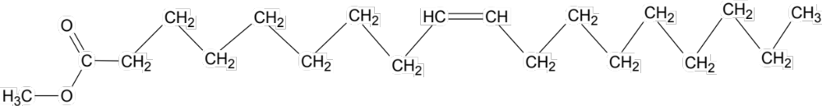

OR

CH₃OOC(CH₂)₇CH=CH(CH₂)₇CH₃

(c) Draw the structures of the two (2) substances that have reacted, in the presence of lipase, to produce the biodiesel shown. (2 marks)

H₂C – OOC(CH₂)₇CH=CH(CH₂)₇CH₃  l  HC – OOC(CH₂)₇CH=CH(CH₂)₇CH₃  l  H₂C – OOC(CH₂)₇CH=CH(CH₂)₇CH₃ | CH₃OH (needs to be drawn)

(d) Name the other substance produced in the reaction referred to in (c), in addition to the biodiesel. (1 mark)

- glycerol (also accept water)

An alternate catalyst for this reaction is sodium hydroxide, NaOH(aq).

(e) State one (1) advantage and one (1) disadvantage of using a base catalyst instead of a lipase catalyst. (2 marks)

Advantage | Faster reaction, more established method, cheaper, will catalyse all different triglycerides… (any relevant point)
Disadvantage | Caustic / corrosive / poisonous, environmentally unfriendly, saponification side reaction / needs higher temps… (any relevant point)

Question 31 (6 marks)

A dihydrogenphosphate / hydrogenphosphate buffer, prepared by mixing NaH₂PO₄(aq) and Na₂HPO₄(aq), was tested to investigate its buffering capacity. The buffer sample was split evenly into two (2) beakers. One of the buffer samples had 2 mol L⁻¹ NaOH(aq) added dropwise while the pH was measured. The second sample had 2 mol L⁻¹ HCl (aq) added dropwise while the pH was measured.

The results of this investigation are shown in the graph below.

Volume of acid / base added
pH
7 -
Buffer + 2 mol L⁻¹ NaOH(aq)
Buffer + 2 mol L⁻¹ HCl (aq)

(a) Write an equation for the buffering system that was prepared. (1 mark)

- H₂PO₄⁻ + H₂O ⇌ HPO₄²⁻ + H₃O⁺
OR
- H₂PO₄⁻ + OH⁻ ⇌ HPO₄²⁻ + H₂O

(b) Which of the following is the most likely composition of the buffer that was being investigated? (tick your choice) (1 mark)

 0.15 mol L⁻¹ NaH₂PO₄(aq) + 0.15 mol L⁻¹ Na₂HPO₄(aq)
✓
 0.15 mol L⁻¹ NaH₂PO₄(aq) + 0.30 mol L⁻¹ Na₂HPO₄(aq)
 0.30 mol L⁻¹ NaH₂PO₄(aq) + 0.15 mol L⁻¹ Na₂HPO₄(aq)
 0.30 mol L⁻¹ NaH₂PO₄(aq) + 0.30 mol L⁻¹ Na₂HPO₄(aq)

(c) Justify your choice of buffer in part (b). Include a definition of buffering capacity in your answer. (4 marks)

- buffering capacity is the extent to which a buffer can maintain a constant pH when strong acid or strong base are added to it (2)

- the graph shows that the solution has a greater capacity to buffer when acid is added
- therefore most likely to be the 0.15/0.3 buffer as this has the greater relative concentration of conjugate base (HPO₄²⁻) present

Question 32 (8 marks)

PHBV is a biodegradable, non-toxic plastic that is produced naturally by some types of bacteria. A fragment of the PHBV polymer is shown below.

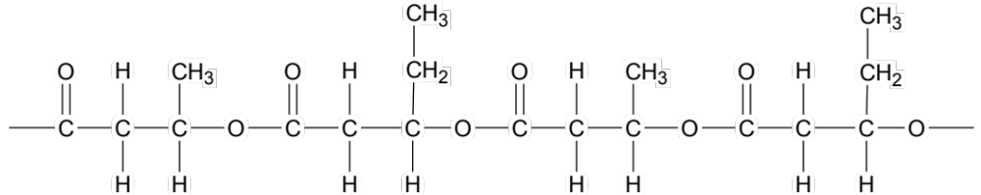

(a) Draw the two (2) monomers from which this copolymer is formed and give the IUPAC name for each. (4 marks)

Structural diagram:  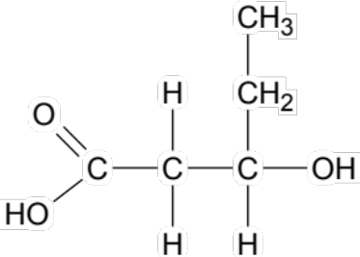 | Structural diagram:  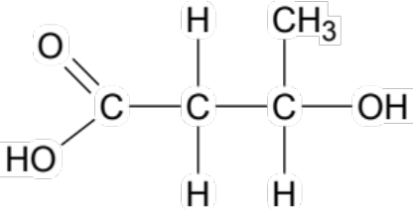
IUPAC name:  3-hydroxypentanoic acid | IUPAC name:  3-hydroxybutanoic acid

(b) Is this polymer a ‘polyester’ or a ‘polyamide’? State your answer below, then circle the ester or amide links in the polymer fragment above. (2 marks)

- polyester (1)
- see diagram above (1)

PHBV is a thermoplastic, which means it melts easily when heat is applied, and lacks the strength of a polymer such as nylon.

(c) Briefly account for the different physical properties of PHBV and nylon. (2 marks)

- PHBV has only dipole-dipole forces present where as nylon has hydrogen bonding
- therefore the intermolecular forces in PHBV would be weaker, resulting in a lower melting point and physical strength than nylon

Question 33 (13 marks)

Some pale yellow crystals of ammonium nitrite (NH₄NO₂) were placed in an empty, sealed flask at Time 0. The ammonium nitrite crystals began to decompose according to the chemical equation shown below.

NH₄NO₂(s) + heat ⇌ N₂(g) + 2 H₂O(g)

Equilibrium was first established at Time E1. At this time, the concentration of nitrogen gas in the flask was 0.2 mol L⁻¹.

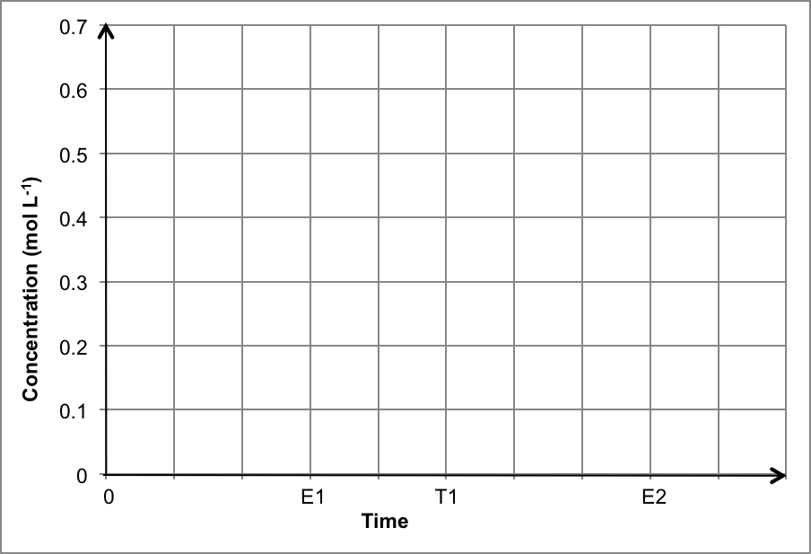
H₂O

N₂

(a) On the axes above, sketch (and label) the concentration of all appropriate species involved in the equilibrium from Time 0 until Time E1. Continue your graph from Time E1 to Time T1, where the system maintained equilibrium. (3 marks)

see solid lines
- N₂ line, must reach 0.2 mol L⁻¹ at E1 (1)
- H₂O line, must reach 0.4 mol L⁻¹ at E1 (1)
- E1 to T1 horizontal (1)

(-1) if line drawn for NH₄NO₂

At Time T1, the temperature of the system was decreased, and equilibrium was then allowed to re-establish. The new equilibrium was established at Time E2.

(b) On the same axes above, continue your sketch from Time T1 until Time E2. (2 marks)

see dashed lines
- N₂ line (1) H₂O line (1)
(lines must be horizontal at E2; does not matter where concentrations finish, as long as they both decrease and the change in H₂O is double the change in N₂)

(c) How would the value of the equilibrium constant (K) at E2 compare to the value at E1? Explain your answer. (3 marks)

- since the temperature decrease has favoured the reverse exothermic direction
- this would decrease the concentration of products
- this would therefore lower the value of K

(d) Explain, in terms of collision theory, the effect of the temperature decrease on the rate of both the forward and reverse reactions, from T1 to E2. (3 marks)

- both forward and reverse would decrease due to a lower average Ek of particles
- the reverse (exothermic) does not decrease as much as the forward (endothermic)
- at E2 the rates are both equal again, but lower than before change imposed

(e) State the effect on the equilibrium position if the following changes were made to the system. (2 marks)

Effect on equilibrium position
(forward favoured, reverse favoured, no change)
More NH₄NO₂(s) crystals were added into the flask | no change
The flask was opened, reducing the pressure of the system | forward favoured

End of Section Two

Section Three: Extended answer 40% (80 marks)

This section contains five (5) questions. You must answer all questions. Write your answers in the spaces provided below.

Where questions require an explanation and/or description, marks are awarded for the relevant chemical content and also for coherence and clarity of expression. Lists or dot points are unlikely to gain full marks.

Final answers to calculations should be expressed to the appropriate number of significant figures.

Spare pages are included at the end of this booklet. They can be used for planning your responses and/or as additional space if required to continue an answer.
- Planning: If you use the spare pages for planning, indicate this clearly at the top of the page.
- Continuing an answer: If you need to use the space to continue an answer, indicate in the original answer space where the answer is continued, i.e. give the page number. Fill in the number of the question(s) that you are continuing to answer at the top of the page.

Suggested working time: 70 minutes.

Question 34 (13 marks)

Fuel cells have several differences when compared to other primary and secondary cells. They require a continuous input of oxidant and reductant, and this allows them to produce a continuous and constant supply of electricity.

The alkaline hydrogen-oxygen fuel cell was one of the earliest fuel cells to be developed. The cell consists of porous nickel electrodes that are coated in a catalyst such as platinum. The electrodes are porous to allow maximum contact between the reactants, the catalyst and the electrodes. It is called the ‘alkaline’ fuel cell, due to the presence of hot concentrated potassium hydroxide (KOH) solution. These cells were first used in the Apollo space shuttles.

(a) Briefly describe the chemistry of the alkaline hydrogen-oxygen fuel cell. Your answer should identify the oxidant (oxidising agent) and the reductant (reducing agent), in addition to stating the function of the potassium hydroxide solution. Include an overall equation for the chemical reaction occurring in the fuel cell. (4 marks)

- oxidant is O₂ [O.N. changes from 0 to -2]
- reductant is H₂ [O.N. changes from 0 to +1]
(only award (1) if ‘oxygen is reduced, hydrogen is oxidised’ is stated, as this does describe the chemistry of the cell but does not identify oxidant and reductant)
- KOH is the electrolyte
- 2 H_{2(g)} + O_{2(l)} → 2 H₂O_{(l)}

An engineer working on the Apollo missions noticed that one of the fuel cells that was to be used in the space shuttles was leaking potassium hydroxide. The potassium hydroxide was dripping from the cell and forming a puddle on the warehouse floor. He knew the concentration of potassium hydroxide used in the cell should be 400 g L⁻¹ and he estimated the size of the puddle to be 1.5 L in volume. The engineer found some 2.75 mol L⁻¹ sulfuric acid solution, H₂SO₄(aq), in the storeroom and poured 1.9 L of this onto the KOH(aq) in order to neutralise the spill.

The neutralisation reaction that took place is as follows;

2 KOH(aq) + H₂SO₄(aq) → K₂SO₄(aq) + 2 H₂O(l)

(b) Based on the engineer’s estimations, determine the limiting reagent. (5 marks)

n(KOH in 400 g) = 400 / 56.108
= 7.129108 mol i.e. c(KOH) = 7.129 mol L⁻¹

n(KOH) = cV = 7.129108 x 1.5 = = 10.69366 mol (1)
n(H₂SO₄) = cV = 2.75 x 1.9 = 5.225 mol (1)
SR of KOH:H₂SO₄ is 2:1 = 2 (1)
AMR of KOH:H₂SO₄ is 10.69366: 5.225 = 2.0466 (1)

SR > AR therefore H₂SO₄ is LR (1)

(c) Based on the engineer’s estimations, calculate the final pH of the puddle and state whether the spill has been effectively neutralised. (4 marks)

n(excess KOH) = 10.69366 - 10.45
= 0.24366 mol (1)

c(excess KOH) = n/V
= 0.24366 / 3.4
= 0.0716647 mol L⁻¹ (1)

[H⁺] = 1.0 x 10⁻¹⁴ / [OH⁻]
= 1.0 x 10⁻¹⁴ / 0.0716647
= 1.39539 x 10⁻¹³ mol L⁻¹ (1)

pH = -log[H⁺]
= -log (1.39539 x 10⁻¹³)
= 12.86
= 13 (2 SF)

i.e. no, the spill has not been neutralised (1)

Question 35 (12 marks)

Periodic acid was discovered in 1833 and comes in two forms; orthoperiodic acid (H₅IO₆) and metaperiodic acid (HIO₄). Orthoperiodic acid is a weak acid, that has a melting point of 128.5 °C and is soluble in both water and alcohol. The orthoperiodic acid molecule has 5 ionisable (acidic) hydrogens, as shown in the diagram below;

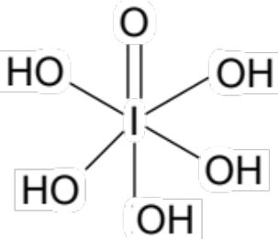

(a) In the table below, write Bronsted-Lowry equations for the first three (3) ionisation steps of orthoperiodic acid. (3 marks)

 | Ionisation equation | Ka value
1. | H₅IO₆ + H₂O ⇌ H₄IO₆⁻ + H₃O⁺ | 5.13 x 10⁻⁴
2. | H₄IO₆⁻ + H₂O ⇌ H₃IO₆²⁻ + H₃O⁺ | 4.90 x 10⁻⁹
3. | H₃IO₆²⁻ + H₂O ⇌ H₂IO₆³⁻ + H₃O⁺ | 2.45 x 10⁻¹²

In no particular order, the values of Ka₁, Ka₂ and Ka₃ are given as;

2.45 x 10⁻¹² 5.13 x 10⁻⁴ 4.90 x 10⁻⁹

(b) Place these values in the table above, next to the corresponding ionisation step. Explain your choice below. (3 marks)

- see table above for values (2) (i.e. (-1) for each mistake)
- each successive ionisation always occurs to a lesser extent, therefore the value of Ka decreases for each ionisation step (1)

Orthoperiodic acid is an oxidising agent (oxidant) of moderate strength. It can be produced from the electrochemical oxidation of iodic acid (HIO₃) using a lead(II) oxide anode.

(c) Write the balanced half-equation for the production of orthoperiodic acid from iodic acid, assuming acidic conditions. (2 marks)

- HIO₃ + 3 H₂O → H₅IO₆ + 2 H⁺ + 2 e⁻ (2)
OR
- IO₃⁻ + 3 H₂O → H₅IO₆ + H⁺ + e⁻ (2)

When heated sufficiently, orthoperiodic acid can be converted to metaperiodic acid, according to the following reaction;

H₅IO₆(aq) + heat ⇌ 2 H₂O(l) + HIO₄(aq)

(+1)(+7)(-2) (+1)(-2) (+1)(+7)(-2)

(d) Use oxidation numbers to demonstrate that this is not a redox reaction. (2 marks)

- States all oxidation numbers as above. (1)
- This is not a redox reaction because oxidation numbers have not changed. (1)

When metaperiodic acid is heated further, the compound diiodine pentoxide (I₂O₅) is formed. Diiodine pentoxide is a water soluble, white crystalline solid which has a melting point of 300 °C.

(e) Write the balanced half-equation for the formation of diiodine pentoxide from metaperiodic acid, assuming acidic conditions. Include phase symbols in your equation. (2 marks)

- 2 HIO₄(aq) + 4 H⁺(aq) + 4 e⁻ → I₂O₅(aq) + 3 H₂O(l)

(1) equation (1) phase symbols

Question 36 (20 marks)

Ethanol (C₂H₅OH) is commonly manufactured by the hydrolysis of ethene. The reaction for this exothermic process is shown below.

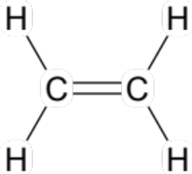 (g) 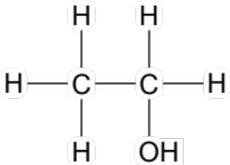(g)
+ H₂O (g) ⇌ + 45 kJ

This reaction is carried out at a temperature of 300 °C and a pressure of 6-7 MPa, in the presence of a phosphoric acid catalyst. The ethene is present in excess, with a 1:0.6 ratio of ethene:steam being introduced into the reaction chamber.

Using these conditions, a 5% yield of ethanol is achieved per pass. However, by collecting the unreacted ethene and steam, and cycling them back through the reaction chamber, an overall yield of 95% can be obtained.

If 385 kg of ethene was added to the reaction chamber;

(a) Calculate the volume of steam, stored at 300 °C and 6.00 MPa, that should be added to the reaction chamber to produce the desired 1:0.6 ratio of reactants? (5 marks)

n(C₂H₄) = m/M
= 385 x 10³ / 28.052 (1) for kg to g
= 13724.5116 mol (1)

n(H₂O) = n(C₂H₄) x 0.6
= 13724.5116 x 0.6
= 8234.70697 mol (1)

V(H₂O) = nRT / P
= (8234.70697 x 8.314 x 573.15) / 6 x 10³ (1) for MPa to kPa
= 6539.96 L
= 6540 L OR 6.54 kL (1)

(b) If the yield is only 5.0 % per pass, what mass of ethanol would be produced in the reaction chamber initially? (3 marks)

n(C₂H₅OH) = n(H₂O) x 5/100
= 8234.70697 x 5/100
= 411.73535 mol (2)

m(C₂H₅OH) = nM
= 411.73535 x 46.068
= 18968 g
= 19 kg (2 SF) (1)

(If students use n(C₂H₄) instead of n(H₂O) from part (a) then final answer will be
m(C₂H₅OH) = 31613 g = 32 kg; award (1) total )

As stated previously, this reaction is carried out at a temperature of 300 °C. This can be referred to as a ‘compromise in conditions’.

(c) Explain why a ‘compromise temperature’ is used. (5 marks)

- a high temperature increases reaction rate
- due to an increased average Ek of particles
- a low temperature increases the yield of ethanol
- due to the favouring of the forward exothermic reaction
- therefore a compromise temperature is used to achieve both a moderate rate and yield
(may also award mark for mention of the ‘economic value of a compromise temperature’)

A moderate pressure is used in the reaction chamber because at high pressures there is an increased risk that polyethene will form instead of ethanol.

(d) Write an equation or draw appropriate structural diagrams to illustrate how this could happen. (2 marks)

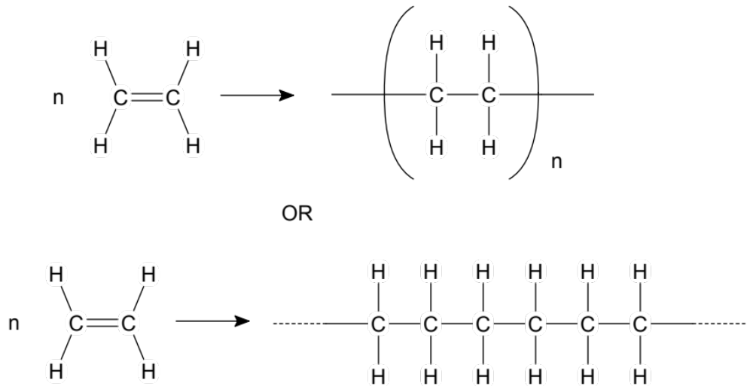

The common alternate method for ethanol synthesis is via the fermentation of glucose. The ethanol formed is referred to as ‘bioethanol’, to indicate the more sustainable production approach used.

(e) Briefly describe why the fermentation method is a more ‘green’ and sustainable process in terms of the temperature, pressure and starting materials used. (5 marks)

- fermentation uses a much lower temperature
- fermentation uses a much lower pressure
- both these factors reduce the energy input of the process
- the starting material for fermentation is a renewable resource / from crops
- this reduces the carbon footprint of the process and makes it more sustainable / less CO₂.

Question 37 (16 marks)

A useful piece of data regarding fats and oils is their ‘saponification value’. Saponification value is defined as ‘the number of milligrams of potassium hydroxide (KOH) required to saponify 1 gram of fat’. The saponification value provides information about the molecular weight of the fat; a lower saponification value indicates a higher molecular weight fat with a longer hydrocarbon chain.

Knowledge of saponification value is important in soap making. Soap can be produced from many different fats and each has a different saponification value. This value will affect the quantities of chemical used in the reaction to produce the soap. Some examples of fats and their saponification values are shown in the table below.

 | Saponification value
Olive oil | 185-196
Linseed oil | 192-195
Palm oil | 196-205
Butter | 220-233
Coconut oil | 246-260

The saponification value of a fat is determined experimentally by a back titration, according to the following procedure.

- Dissolve 1.00 g of fat in 10.00 mL of ethanol-ether-solvent.

- Add 25.00 mL of 0.500 mol L⁻¹ KOH solution. This ensures the KOH is in excess. The general saponification reaction that takes place is shown in the following equation.

fat(s) + 3 KOH(aq) → 3 potassium fatty acid salt(aq) + glycerol(l)

- Place the sample in a water bath at 100 °C for 30 minutes to ensure all the fat has reacted. Cool the sample.

- Add several drops of phenolphthalein to the saponified sample. A pink colour should be observed, confirming excess KOH(aq).

- Back titrate the sample with 0.500 mol L⁻¹ HCl(aq) until the end point is reached. This allows the amount of KOH(aq) remaining to be determined.

KOH(aq) + HCl(aq) → KCl(aq) + H₂O(l)

Some chemistry students carried out this procedure on a sample of unknown fat. They repeated the process five (5) times. Their incomplete titration data is shown in the table below.

 | 1 | 2 | 3 | 4 | 5
Initial reading (mL) | 47.25 | 29.60 | 48.50 | 31.75 | 20.95
Final reading (mL) | 29.60 | 12.80 | 31.75 | 14.90 | 4.55
Titre (mL) | 17.65 | 16.80 | 16.75 | 16.85 | 16.40

The final burette reading for Trial 5 is shown below right.
6 mL

5 mL

4 mL

3 mL

(a) Read the final burette value to the appropriate degree
of accuracy and record it in the table. Then calculate
the average titre that should be used. (2 marks)

- see table for reading (4.55 mL)
- average (of trial 2, 3 & 4) = 16.80 mL (not 16.8 mL or 16.80 without unit)

(b) Use the titration data, as well as the initial data on KOH(aq) given in Step 2, to calculate the number of moles of KOH(aq) that reacted with the fat. (4 marks)

n(KOH initially) = cV
= 0.5 x 0.025
= 0.0125 mol

n(HCl from burette) = cV
= 0.5 x 0.01680
= 0.0084 mol

= n(KOH remaining after saponification)

n(KOH reacted with fat) = 0.0125 – 0.0084 mol
= 0.0041 mol

(c) Calculate the saponification value for this fat and identify the fat using the values given in the saponification table. (3 marks)

m(KOH) = nM
= 0.0041 x 56.108
= 0.2300428 g

Saponification value = 0.2300428 x 1000
= 230 mg (3 SF)

The fat is butter

(d) Calculate the molecular weight of this fat. (2 marks)

n(fat) = n(KOH) / 3
= 0.0041 / 3
= 0.00136667 mol

M(fat) = m/n
= 1/0.00136667
= 731.71 g mol⁻¹
= 732 g mol⁻¹ (3 SF)

The students decided to use the data from this experiment to make some small bars of soap, which they sold at the school fete to raise money for their school.

(e) Explain why soap molecules have a slightly basic pH. (2 marks)

- soap is a sodium/potassium salt of a fatty acid, which are weak acids / soap molecules are conjugate bases of weak acids
- therefore the soap anion (the surfactant ion) is basic as it will hydrolyse with water to produce OH⁻ ions

(f) Briefly explain how soap is able to clean oily food particles off hands. (3 marks)

- the hydrophobic non-polar region of the soap molecule/surfactant ion dissolves in the oil
- the hydrophilic polar region of the soap molecule/surfactant ion dissolves in water
- with agitation, the oil is removed from your hands

(accept and award marks also for relevant diagrams in explanation)

Question 38 (19 marks)

‘Copper peptide GHK’ (also written GHK-Cu) is a tripeptide composed of the amino acids glycine, histidine and lysine (gly-his-lys). GHK-Cu is found in blood plasma, urine and saliva. Studies have shown that GHK-Cu plays an important role in healing wounds. In one animal study, it was observed that the presence of GHK-Cu increased the rate of healing threefold.

(a) Draw a structural diagram of the GHK-Cu tripeptide. (3 marks)

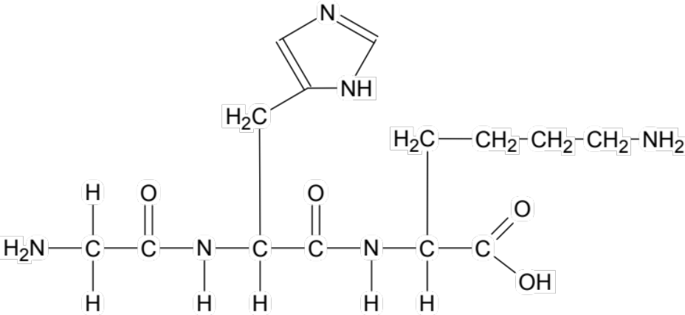

accept also a diagram drawn in zwitterion form

The GHK-Cu tripeptide functions due to the ability of the amino acid lysine to interact with copper(II) ions. A diagram of lysine, at physiological pH, is shown below.

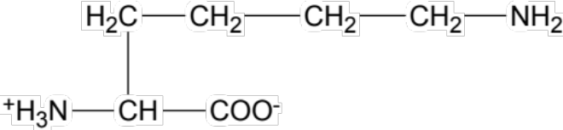
basic
acidic

(b) Define a ‘zwitterion’. Circle and label the acidic and basic groups on the diagram of lysine shown above. (3 marks)

- a zwitterion is a species that has both a positive and negative charge but is overall a neutral molecule (1)
- see diagram above (2)

In the GHK-Cu tripeptide, the lysine residue is only able to interact with copper(II) ions at an alkaline pH.

(c) Draw the structure of lysine at pH 14 (i.e. strongly alkaline). (1 mark)

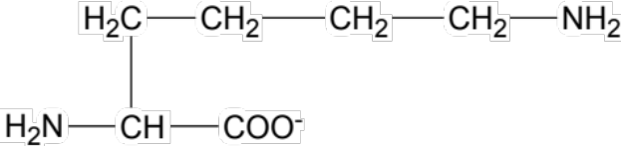
One of the amino acid residues from GHK-Cu was isolated and analysed by combustion. A 2.73 g sample of the amino acid was burnt in oxygen, and this produced 4.92 g of carbon dioxide and 2.35 g of water vapour. A volume of 440 mL of nitrogen gas (N₂) was also captured, at 220 °C and 174 kPa.

(d) Determine the empirical formula of this amino acid. (10 marks)

m(C) = 12.01 / 44.01 x 4.92
= 1.34263 g

m(H) = 2.016 / 18.016 x 2.35
= 0.262966 g

n(N₂) = PV/RT
= (174 x 0.440) / (8.314 x 493.15)
= 0.0186729 mol

n(N) = 2 x n(N₂)
= 0.03734589 mol

m(N) = nM
= 0.03734589 x 14.01
= 0.523216 g

m(O) = 2.73 – m(c) – m(H) – m(N)
= 0.6011877 g

 | C | H | N | O
m | 1.34263 | 0.262966 | 0.523216 | 0.6011877
n | 1.34263 / 12.01  = 0.1117927 | 0.262966 / 1.008  = 0.260879 | 0.523216 / 14.01  = 0.0373459 | 0.6011877 / 16.00  = 0.037574
ratio | 3 | 7 | 1 | 1

Therefore EF is C₃H₇NO

(e) Identify which of the amino acids in GHK-Cu had been isolated and analysed. Justify your answer. (2 marks)

- amino acid is lysine
- the MF of lysine is C₆H₁₄N₂O₂ which corresponds to 2 x EF (neither histidine [MF C₆H₉N₃O₂] or glycine [MF C₂H₅NO₂] have an MF that matches the EF or is a multiple of the EF)

End of questions

